TME Enhancement for Programs

**Purpose:** This document specifies functional requirements and software design for addition of a “Programs” tier for grouping projects in the Task Management Environment. A task may be related to a specific milestone or directly related to a specific project without being related to a milestone. A milestone is always related to a specific project for a specific project manager. The purpose of this enhancement is to group related projects that may or may not have different project managers. This grouping of projects will be referred to as a “Program.”

**Requirements:** BAs need a capability to “see” related projects on a page for expanding projects, milestones, and tasks. This will require a means for creating programs for association with projects. Projects shall be related to programs on a many to one or none basis. Not all projects need to be related to a program. Only when many projects are created for the same set of capabilities are programs needed to relate them to each other.

**Data:** A new DB table (Tme_Program) is needed for the program entity that contains attributes for program title, program scope, status (A or I), and program ID. In addition, a new column needs to be added to the Tme_Project table for the associated program ID.

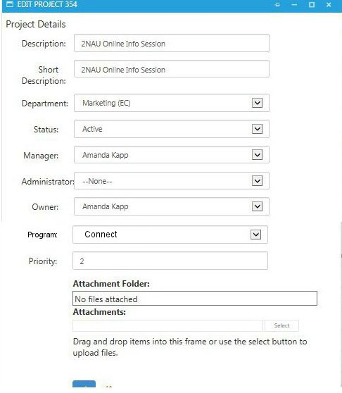

CREATE TABLE dbo.Tme_Program (

Program_ID int not null Primary Key,

Title Varchar(50) not null,

Program_Scope ntext null,

Status Char(1) not null

)

ALTER TABLE [Distance].[dbo].[Tme_Project]

ADD FOREIGN KEY (Program_ID)

REFERENCES dbo.Tme_Program(Program_ID)

**User Interface:** The projects menu item would remain the same. However, the “Edit Project” modal available through the pencil icon on the projects.aspx page will need an additional dropdown for selection of a program. The default would be none because projects are not required to be associated with a program.

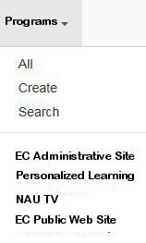

A dropdown menu item for the TME menu at the top of the TME pages needs to be added for “Programs.” The function and appearance should be the same as the dropdown for “Projects” with the exception that instead of a list of project manager names below the options for All, Create, and Search, there would be a list of active program titles below the options for All Create, and Search. The “Search” option would allow for search of all programs and the “All” option would list all programs, both active and inactive. The Create option would allow the creation of a new program and therefore populate the programs database table described above.

The selection of “All” or one of the programs shall produce a page similar to the projects page. The programs page will be different in that it will list project for the selected program. If a specific program is selected, the heading above the column headings will show the program and scope from the database and indicate the current status with an option to change the status.

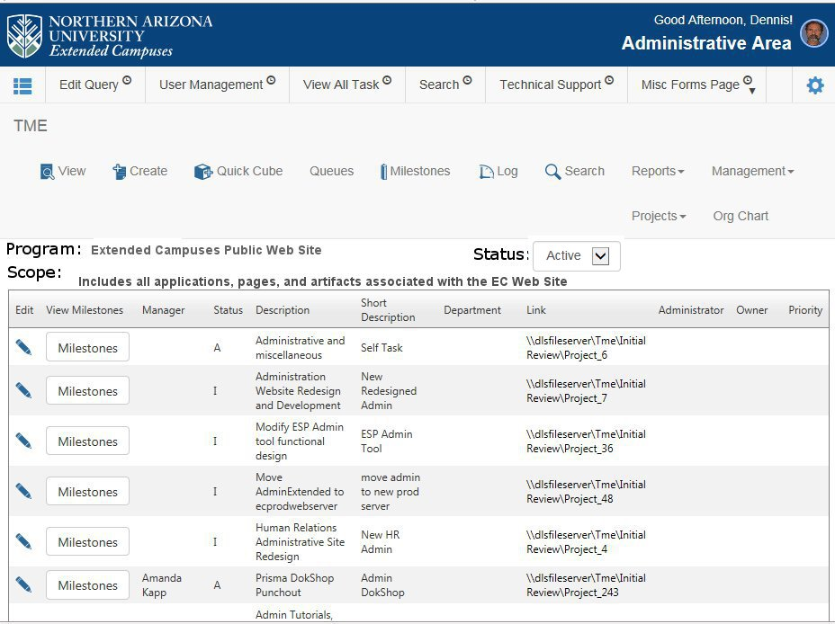

Listed projects may be edited just as they are with the projects page and the selection of a milestone will display a list of the milestones for the project just as it does with the projects page. Finally, selecting one of the milestones from that list will open the milestone.aspx page with options similar to the Proj_MileID=nn only for the selected program as Prog_Mile_ID=nn. The milestone page would show the selected milestone expanded and all of the other projects for the program in the list.

